### **Project 15：Multi-purpose Smart Home Kit**

**Description**

In the previous projects, we introduce how to use sensors, modules and HM-10 Bluetooth module. For this lesson, we will perform all functions We will achieve the effect as follows:

* Photocell sensor, PIR motion sensor and LED. When at night, someone passes by, LED is on; nobody is around, the LED is off.
* There are 1602LCD display, 2 buttons, 1 servo on the board. Press button1 to enter the password(you can set password in the test code), the 1602LCD will show “*”, then press button2 to “ensure”. If the password is correct, the 1602LCD will show “open”, the door will be open. However, if the password is wrong, the “error” pops up , after 2s, “error” will turn into “again” , you can enter password again.

The door will be closed when PIR motion sensor doesn’t detect people around. What’s more, press and hold button2, buzzer will sound, LCD displays “wait”.（If the password is right, the servo will rotate to 180°, otherwise，the servo don’t rotate）

Note: The correct password is ”. - - . - .” which means that **short press button1, long press button1, long press button1, short press button1, long press button1, short press button1.**

”- ”means **long press button1**, ”.”means **short press button1**

* Insert soil humidity into plant pot, when the soil is too dry, buzzer will alarm and you will get the notification on app.
* When the gas sensor detects the gas with high concentration, the buzzer emits a "tick,tick" alarm sound.
* When steam sensor detects rains, the servo 2 will be activated, the window will be closed automatically, otherwise, the window will be open.

**Equipment：**

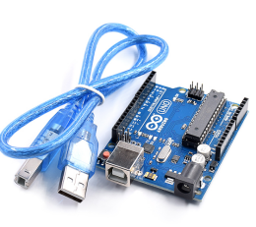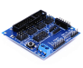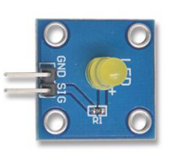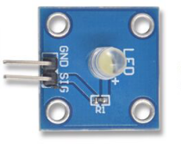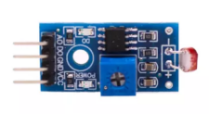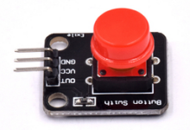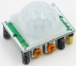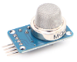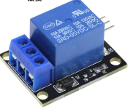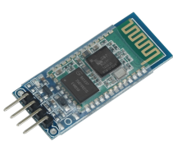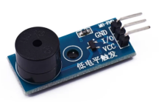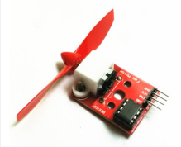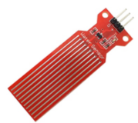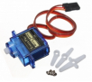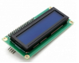

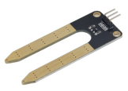

**Connection Diagram：**

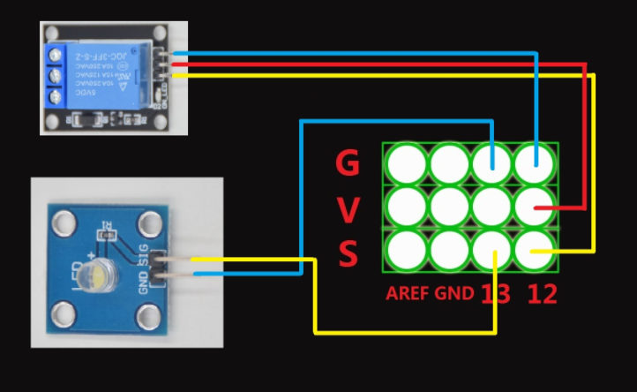

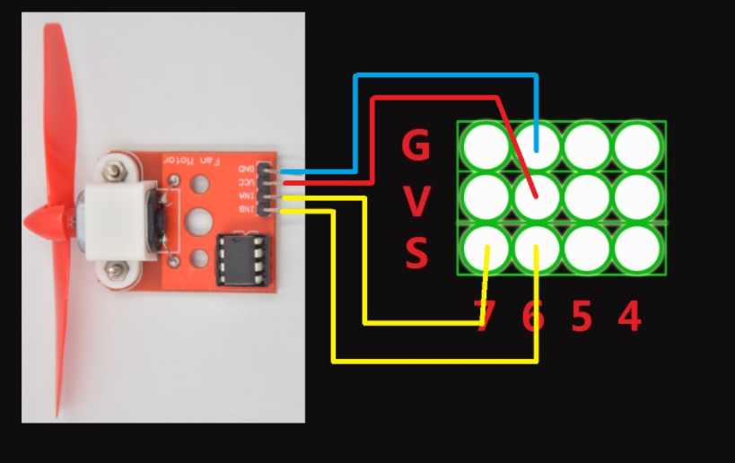

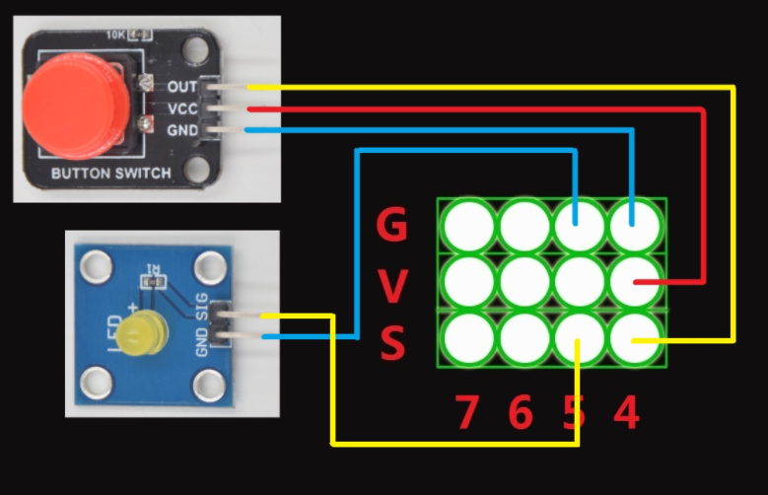

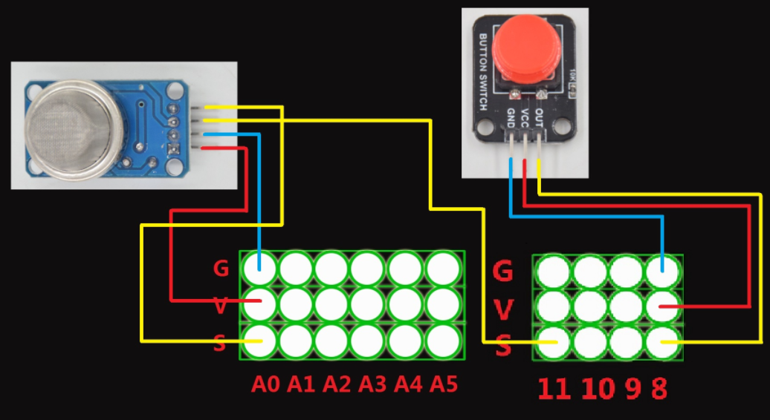

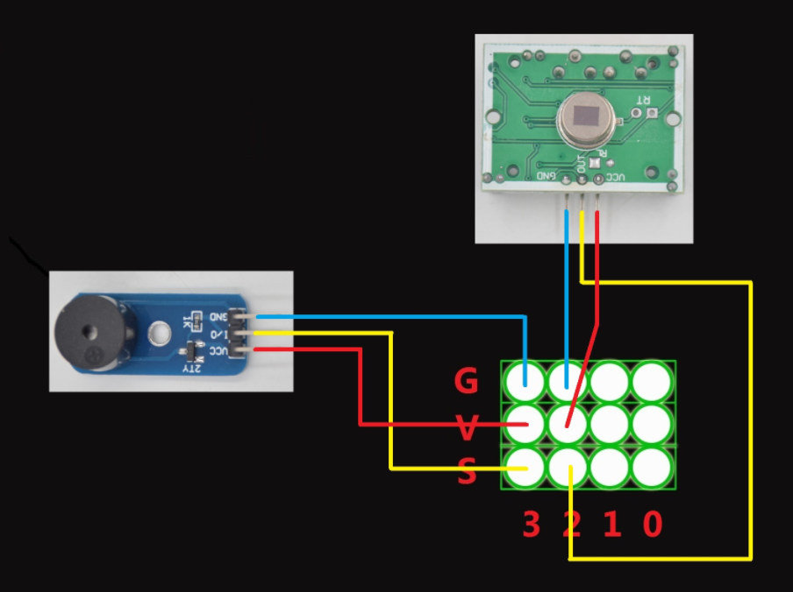

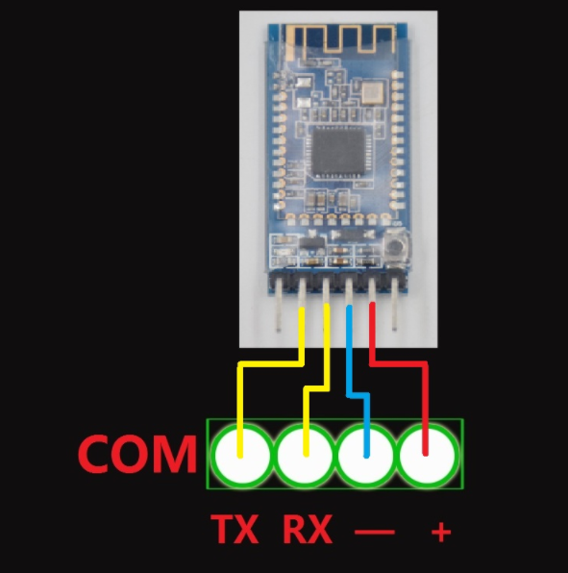

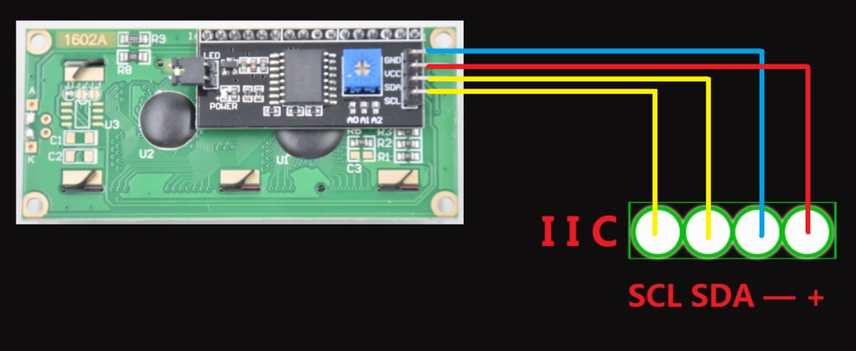

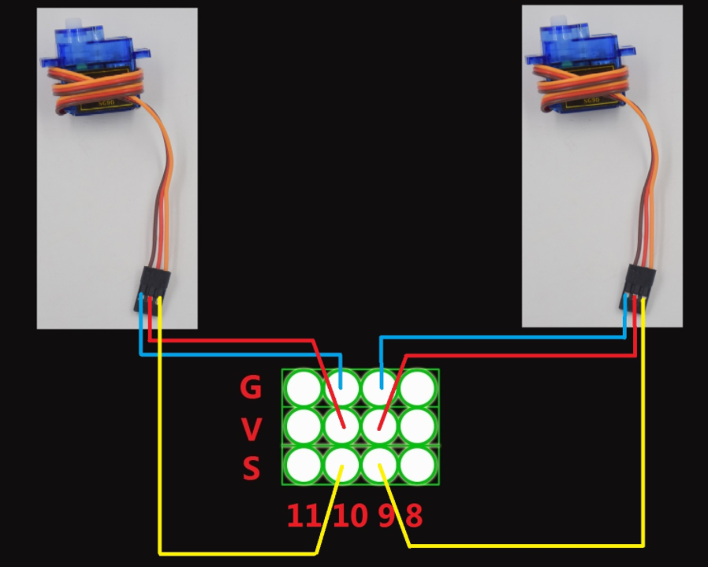

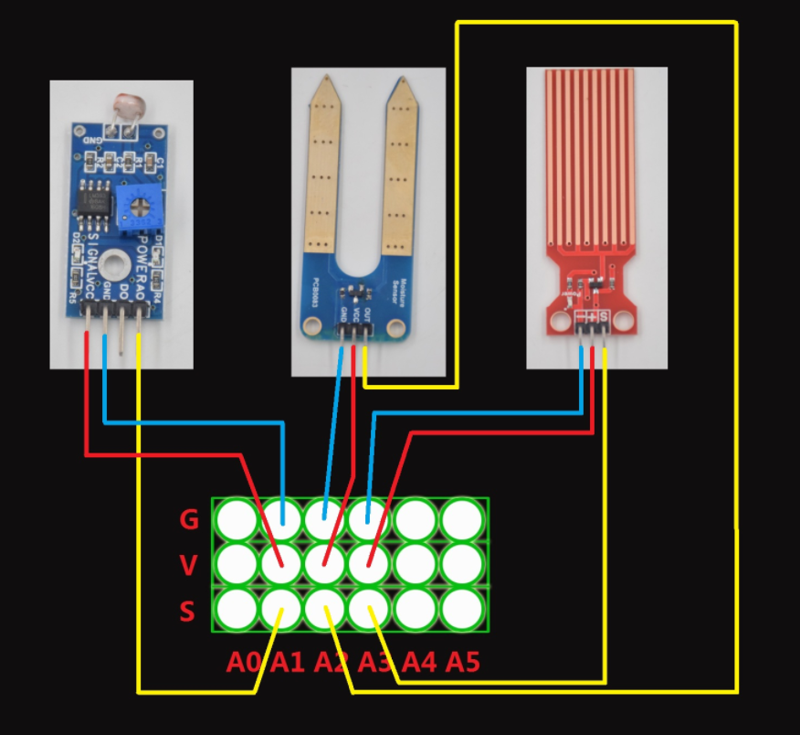

**Test Code：**

//call the relevant library file

#include <Servo.h>

#include <Wire.h>

#include <LiquidCrystal_I2C.h>

//Set the communication address of I2C to 0x27, display 16 characters every line, two lines in total

LiquidCrystal_I2C mylcd(0x27, 16, 2);

//set ports of two servos to digital 9 and 10

Servo servo_10;

Servo servo_9;

volatile int btn1_num;//set variable btn1_num

volatile int btn2_num;//set variable btn2_num

volatile int button1;//set variable button1

volatile int button2;//set variable button2

String fans_char;//string type variable fans_char

volatile int fans_val;//set variable fans_char

volatile int flag;//set variable flag

volatile int flag2;//set variable flag2

volatile int flag3;//set variable flag3

volatile int gas;//set variable gas

volatile int infrar;//set variable infrar

String led2;//string type variable led2

volatile int light;//set variable light

String pass;//string type variable pass

String passwd;//string type variable passwd

String servo1;//string type variable servo1

volatile int servo1_angle;//set variable light

String servo2;//string type variable servo2

volatile int servo2_angle;//set variable servo2_angle

volatile int soil;//set variable soil

volatile int val;//set variable val

volatile int value_led2;//set variable value_led2

volatile int water;//set variable water

int length;

int tonepin = 3; //set the signal end of passive buzzer to digital 3

//define name of every sound frequency

#define D0 -1

#define D1 262

#define D2 293

#define D3 329

#define D4 349

#define D5 392

#define D6 440

#define D7 494

#define M1 523

#define M2 586

#define M3 658

#define M4 697

#define M5 783

#define M6 879

#define M7 987

#define H1 1045

#define H2 1171

#define H3 1316

#define H4 1393

#define H5 1563

#define H6 1755

#define H7 1971

#define WHOLE 1

#define HALF 0.5

#define QUARTER 0.25

#define EIGHTH 0.25

#define SIXTEENTH 0.625

//set sound play frequency

int tune[] =

{

M3, M3, M4, M5,

M5, M4, M3, M2,

M1, M1, M2, M3,

M3, M2, M2,

M3, M3, M4, M5,

M5, M4, M3, M2,

M1, M1, M2, M3,

M2, M1, M1,

M2, M2, M3, M1,

M2, M3, M4, M3, M1,

M2, M3, M4, M3, M2,

M1, M2, D5, D0,

M3, M3, M4, M5,

M5, M4, M3, M4, M2,

M1, M1, M2, M3,

M2, M1, M1

};

//set music beat

float durt[] =

{

1, 1, 1, 1,

1, 1, 1, 1,

1, 1, 1, 1,

1 + 0.5, 0.5, 1 + 1,

1, 1, 1, 1,

1, 1, 1, 1,

1, 1, 1, 1,

1 + 0.5, 0.5, 1 + 1,

1, 1, 1, 1,

1, 0.5, 0.5, 1, 1,

1, 0.5, 0.5, 1, 1,

1, 1, 1, 1,

1, 1, 1, 1,

1, 1, 1, 0.5, 0.5,

1, 1, 1, 1,

1 + 0.5, 0.5, 1 + 1,

};

void setup() {

Serial.begin(9600);//set baud rate to 9600

mylcd.init();

mylcd.backlight();//initialize LCD

//LCD shows "passcord:" at first row and column

mylcd.setCursor(1 - 1, 1 - 1);

mylcd.print("passcord:");

servo_9.attach(9);//make servo connect to digital 9

servo_10.attach(10);//make servo connect to digital 10

servo_9.write(0);//set servo connected digital 9 to 0°

servo_10.write(0);//set servo connected digital 10 to 0°

delay(300);

pinMode(7, OUTPUT);//set digital 7 to output

pinMode(6, OUTPUT);//set digital 6 to output

digitalWrite(7, HIGH); //set digital 7 to high level

digitalWrite(6, HIGH); //set digital 6 to high level

pinMode(4, INPUT);//set digital 4 to input

pinMode(8, INPUT);//set digital 8 to input

pinMode(2, INPUT);//set digital 2 to input

pinMode(3, OUTPUT);//set digital 3 to output

pinMode(A0, INPUT);//set A0 to input

pinMode(A1, INPUT);//set A1 to input

pinMode(13, OUTPUT);//set digital 13 to input

pinMode(A3, INPUT);//set A3 to input

pinMode(A2, INPUT);//set A2 to input

pinMode(12, OUTPUT);//set digital 12 to output

pinMode(5, OUTPUT);//set digital 5 to output

pinMode(3, OUTPUT);//set digital 3 to output

length = sizeof(tune) / sizeof(tune[0]); //set the value of length

}

void loop() {

auto_sensor();

if (Serial.available() > 0) //serial reads the characters

{

val = Serial.read();//set val to character read by serial Serial.println(val);//output val character in new lines

pwm_control();

}

switch (val) {

case 'a'://if val is character 'a'，program will circulate

digitalWrite(13, HIGH); //set digital 13 to high level，LED lights up

break;//exit loop

case 'b'://if val is character 'b'，program will circulate

digitalWrite(13, LOW); //Set digital 13 to low level, LED is off

break;//exit loop

case 'c'://if val is character 'c'，program will circulate

digitalWrite(12, HIGH); //set digital 12 to high level，NO of relay is connected to COM

break;//exit loop

case 'd'://if val is character 'd'，program will circulate

digitalWrite(12, LOW); //set digital 12 to low level，NO of relay is disconnected to COM

break;//exit loop

case 'e'://if val is character 'e'，program will circulate

music1();//play birthday song

break;//exit loop

case 'f'://if val is character 'f'，program will circulate

music2();//play ode to joy song

break;//exit loop

case 'g'://if val is character 'g'，program will circulate

noTone(3);//set digital 3 to stop playing music

break;//exit loop

case 'h'://if val is character 'h'，program will circulate

Serial.println(light);//output the value of variable light in new lines

delay(100);

break;//exit loop

case 'i'://if val is character 'i'，program will circulate

Serial.println(gas);//output the value of variable gas in new lines

delay(100);

break;//exit loop

case 'j'://if val is character 'j'，program will circulate

Serial.println(soil);//output the value of variable soil in new lines

delay(100);

break;//exit loop

case 'k'://if val is character 'k'，program will circulate

Serial.println(water);//output the value of variable water in new lines

delay(100);

break;//exit loop

case 'l'://if val is character 'l'，program will circulate

servo_9.write(180);//set servo connected to digital 9 to 180°

delay(500);

break;//exit loop

case 'm'://if val is character 'm'，program will circulate

servo_9.write(0);;//set servo connected to digital 9 to 0°

delay(500);

break;//exit loop

case 'n'://if val is character 'n'，program will circulate

servo_10.write(180);//set servo connected to digital 10 to 180°

delay(500);

break;//exit loop

case 'o'://if val is character 'o'，program will circulate

servo_10.write(0);//set servo connected to digital 10 to 0°

delay(500);

break;//exit loop

case 'p'://if val is character 'p'，program will circulate

digitalWrite(5, HIGH); //set digital 5 to high level, LED is on

break;//exit loop

case 'q'://if val is character 'q'，program will circulate

digitalWrite(5, LOW); // set digital 5 to low level, LED is off

break;//exit loop

case 'r'://if val is character 'r'，program will circulate

digitalWrite(7, LOW);

digitalWrite(6, HIGH); //fan rotates anticlockwise at the fastest speed

break;//exit loop

case 's'://if val is character 's'，program will circulate

digitalWrite(7, LOW);

digitalWrite(6, LOW); //fan stops rotating

break;//exit loop

}

}

////////////////////////set birthday song//////////////////////////////////

void birthday()

{

tone(3, 294); //digital 3 outputs 294HZ sound

delay(250);//delay in 250ms

tone(3, 440);

delay(250);

tone(3, 392);

delay(250);

tone(3, 532);

delay(250);

tone(3, 494);

delay(500);

tone(3, 392);

delay(250);

tone(3, 440);

delay(250);

tone(3, 392);

delay(250);

tone(3, 587);

delay(250);

tone(3, 532);

delay(500);

tone(3, 392);

delay(250);

tone(3, 784);

delay(250);

tone(3, 659);

delay(250);

tone(3, 532);

delay(250);

tone(3, 494);

delay(250);

tone(3, 440);

delay(250);

tone(3, 698);

delay(375);

tone(3, 659);

delay(250);

tone(3, 532);

delay(250);

tone(3, 587);

delay(250);

tone(3, 532);

delay(500);

}

//detect gas

void auto_sensor() {

gas = analogRead(A0);//assign the analog value of A0 to gas

if (gas > 700) {

//if variable gas>700

flag = 1;//set variable flag to 1

while (flag == 1)

//if flag is 1, program will circulate

{

Serial.println("danger");//output "danger" in new lines

tone(3, 440);

delay(125);

delay(100);

noTone(3);

delay(100);

tone(3, 440);

delay(125);

delay(100);

noTone(3);

delay(300);

gas = analogRead(A0);//gas analog the value of A0 to gas

if (gas < 100) //if variable gas is less than 100

{

flag = 0;//set variable flag to 0

break;//exit loop exist to loop

}

}

} else

//otherwise

{

noTone(3);// digital 3 stops playing music

}

light = analogRead(A1);////Assign the analog value of A1 to light

if (light < 300)//if variable light is less than 300

{

infrar = digitalRead(2);//assign the value of digital 2 to infrar

Serial.println(infrar);//output the value of variable infrar in new lines

if (infrar == 1)

// if variable infra is 1

{

digitalWrite(13, HIGH); //set digital 13 to high level, LED is on

} else//Otherwise

{

digitalWrite(13, LOW); //set digital 13 to low level, LED is off

}

}

water = analogRead(A3);//assign the analog value of A3 to variable water

if (water > 800)

// if variable water is larger than 800

{

flag2 = 1;//if variable flag 2 to 1

while (flag2 == 1)

// if flag2 is 1, program will circulate

{

Serial.println("rain");//output "rain" in new lines

servo_10.write(180);// set the servo connected to digital 10 to 180°

delay(300);//delay in 300ms

delay(100);

water = analogRead(A3);;//assign the analog value of A3 to variable water

if (water < 30)// if variable water is less than 30

{

flag2 = 0;// set flag2 to 0

break;//exit loop

}

}

} else//Otherwise

{

if (val != 'u' && val != 'n')

//if val is not equivalent 'u' either 'n'

{

servo_10.write(0);//set servo connected to digital 10 to 0°

delay(10);

}

}

soil = analogRead(A2);//assign the analog value of A2 to variable soil

if (soil > 50)

// if variable soil is greater than 50

{

flag3 = 1;//set flag3 to 1

while (flag3 == 1)

//If set flag3 to 1, program will circulate

{

Serial.println("hydropenia ");//output "hydropenia " in new lines

tone(3, 440);

delay(125);

delay(100);

noTone(3);

delay(100);

tone(3, 440);

delay(125);

delay(100);

noTone(3);//digital 3 stops playing sound

delay(300);

soil = analogRead(A2);//Assign the analog value of A2 to variable soil

if (soil < 10)//If variable soil<10

{

flag3 = 0;//set flag3 to 0

break;//exit loop

}

}

} else//Otherwise

{

noTone(3);//set digital 3 to stop playing music

}

door();//run subroutine

}

void door() {

button1 = digitalRead(4);// assign the value of digital 4 to button1

button2 = digitalRead(8);//assign the value of digital 8 to button2

if (button1 == 0)//if variablebutton1 is 0

{

delay(10);//delay in 10ms

while (button1 == 0) //if variablebutton1 is 0，program will circulate

{

button1 = digitalRead(4);// assign the value of digital 4 to button1

btn1_num = btn1_num + 1;//variable btn1_num plus 1

delay(100);// delay in 100ms

}

}

if (btn1_num >= 1 && btn1_num < 5) //1≤if variablebtn1_num<5

{

Serial.print(".");

Serial.print("");

passwd = String(passwd) + String(".");//set passwd

pass = String(pass) + String(".");//set pass

//LCD shows pass at the first row and column

mylcd.setCursor(1 - 1, 2 - 1);

mylcd.print(pass);

}

if (btn1_num >= 5)

//if variablebtn1_num ≥5

{

Serial.print("-");

passwd = String(passwd) + String("-");//Set passwd

pass = String(pass) + String("-");//set pass

//LCD shows pass at the first row and column

mylcd.setCursor(1 - 1, 2 - 1);

mylcd.print(pass);

}

if (button2 == 0) //if variablebutton2 is 0

{

delay(10);

if (button2 == 0)//if variablebutton2 is 0

{

if (passwd == ".--.-.")//if passwd is ".--.-."

{

mylcd.clear();//clear LCD screen

//LCD shows "open!" at first character on second row

mylcd.setCursor(1 - 1, 2 - 1);

mylcd.print("open!");

servo_9.write(100);//set servo connected to digital 9 to 100°

delay(300);

delay(5000);

passwd = "";

pass = "";

mylcd.clear();//clear LCD screen

//LCD shows "password:"at first character on first row

mylcd.setCursor(1 - 1, 1 - 1);

mylcd.print("password:");

} else //Otherwise

{

mylcd.clear();//clear LCD screen

//LCD shows "error!"at first character on first row

mylcd.setCursor(1 - 1, 1 - 1);

mylcd.print("error!");

passwd = "";

pass = "";

delay(2000);

//LCD shows "again" at first character on first row

mylcd.setCursor(1 - 1, 1 - 1);

mylcd.print("again");

}

}

}

infrar = digitalRead(2);//assign the value of digital 2 to infrar

if (infrar == 0 && (val != 'l' && val != 't'))

//if variable infrar is 0 and val is not 'l' either 't'

{

servo_9.write(0);//set servo connected to digital 9 to 0°

delay(50);

}

if (button2 == 0)//if variablebutton2 is 0

{

delay(10);

while (button2 == 0) //if variablebutton2 is 0，program will circulate

{

button2 = digitalRead(8);//assign the value of digital 8 to button2

btn2_num = btn2_num + 1;//variable btn2_num plus 1

delay(100);

if (btn2_num >= 15)//if variablebtn2_num ≥15

{

tone(3, 532);

delay(125);

mylcd.clear();//clear LCD screen

//LCD shows "password:" at the first character on first row

mylcd.setCursor(1 - 1, 1 - 1);

mylcd.print("password:");

//LCD shows "wait" at the first character on first row

mylcd.setCursor(1 - 1, 1 - 1);

mylcd.print("wait");

} else//Otherwise

{

noTone(3);//digital 3 stops playing music

}

}

}

btn1_num = 0;//set btn1_num to 0

btn2_num = 0;//set btn2_num to 0

}

// Birthday song

void music1() {

birthday();

}

//Ode to joy

void music2() {

Ode_to_Joy();

}

void Ode_to_Joy()//play Ode to joy song

{

for (int x = 0; x < length; x++)

{

tone(tonepin, tune[x]);

delay(300 * durt[x]);

}

}

//PWM control

void pwm_control() {

switch (val)

{

case 't'://if val is 't'，program will circulate

servo1 = Serial.readStringUntil('#');

servo1_angle = String(servo1).toInt();

servo_9.write(servo1_angle);//set the angle of servo connected to digital 9 to servo1_angle

delay(300);

break;//exit loop

case 'u'://if val is 'u'，program will circulate

servo2 = Serial.readStringUntil('#');

servo2_angle = String(servo2).toInt();

servo_10.write(servo2_angle);//set the angle of servo connected to digital 10 to servo2_angle

delay(300);

break;//exit loop

case 'v'://if val is 'v'，program will circulate

led2 = Serial.readStringUntil('#');

value_led2 = String(led2).toInt();

analogWrite(5, value_led2); //PWM value of digital 5 is value_led2

break;//exit loop

case 'w'://if val is 'w'，program will circulate

fans_char = Serial.readStringUntil('#');

fans_val = String(fans_char).toInt();

digitalWrite(7, LOW);

analogWrite(6, fans_val); //set PWM value of digital 6 to fans_val，the larger the value, the faster the fan

break;//exit loop

}

}

Upload the code and see the result！

Note: Remove the Bluetooth module please, when uploading the test code. Otherwise, the program will fail to upload. Connect the Bluetooth and Bluetooth module to pair after uploading the test code.